Southside Friday, April 20, 2025

You are cordially invited to participate in the next ***Oil City Uncorked*** event! ***Oil City Uncorked*** is a bi-annual, four-hour tasting event held in the downtown business district of Oil City, PA. Each ticketholder receives an event wristband once they present a valid photo ID to our volunteers at check-in and a souvenir glass for sampling. We provide a Beverage Check at a nearby location and will provide all vendors with an organized claim ticket system to enable smooth pickup for those who purchase beverages. The event is promoted via social media, email blasts, press releases, radio, and on our website, [oilcitymainstreet.org](http://www.oilcitymainstreet.org).

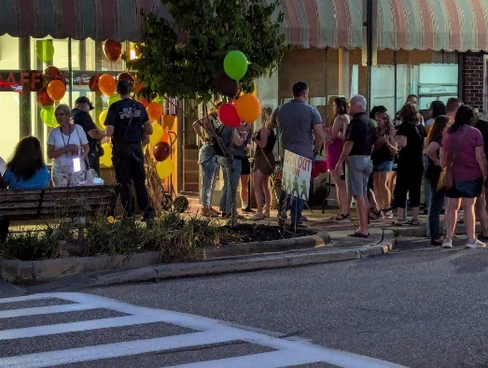**Event details are as follows:**  Event Date: Friday, April 25, 2025  
Set-up Time: 4 p.m. - 5 p.m.  
Event Time: 5:30 p.m. -8:30 p.m.   
Location: Downtown Oil City, PA (Southside)  
Tickets: $30 advance, $35 day of event, $5 DD at door only   
Vendor fee: $50, & one bottle of your choice  
Turnout: 350-500 expected.

**We ask that participating vendors please:**

* Establish contact with your host as soon as you receive confirmation details from OCMS
* **Arrive at your host site** no later than 4 p.m. on event day
* **Follow our claim ticket system** for beverage purchases as directed on event day
* Bring enough product for 400 samples or more (please do not sell beverages by the glass at this event)
* Provide a product list & descriptions plus your bags, spouts, corkscrew, dump bucket & any other supplies
* **Provide PLCB permit and a certificate of insurance** before the event (Oil Region Alliance, Inc. listed as additional insured; also list host venue if requested)

Participating Hosts are asked to provide a table or counter for the wine-tasting station, light appetizers, and a representative to validate the wine map (entry form for the wine gift basket prize).

**TO PARTICIPATE: Please complete & return the attached Vendor Registration Form with payment ASAP or by February 15, 2025.** We will confirm your participation by early March, notify you when ticket sales begin, and update you on event details. We look forward to the next ***Oil City Uncorked*** and hope you join us!

Stevette Rosen

Stevette Rosen, Main Street Manager  
217 Elm Street, Oil City PA 16301  
(814) 677-3152 x101  
srosen@oilregion.org

**Vendor Agreement**

Friday, April 25, 2025

Company Name: ______________________________________________________________________________

Authorized Representative: ____________________________________________Cell Phone: ________________

Event Day Contact: __________________________________________________ Cell Phone: ________________

Address: _______________________________ City: _________________ State: ________ ZIP: ______________

Email: __________________________________________ Business Phone: ______________________________

Products you wish to provide samples of *(Please specify i.e., sweet, dry, etc.):* _____Please try to provide at least two dry _________________________

____________________________________________________________________________________________

**Vendor must provide to Oil City Main Street Program:** 🞏 PLCB Permit.

🞏 Certificate of Insurance (Oil Region Alliance listed as additional insured)

**Registration fee:** _____ Check enclosed for $50 vendor fee

_____ vendor will contribute one bottle or more for the prize baskets

**COMPLETED FORMS, DOCUMENTS AND PAYMENT MUST BE RECEIVED BY February 15, 2025**

**Licensing papers can be turned in later by April1, 2025**

The Oil City Main Street Program reserves the right to refuse participation to any vendor for any reason. No refunds for ANY reason. Each participant is subject to all city, state and federal laws and ordinances.

**Day of Event: Vendors must be on-site and set up by 4 p.m.** **The event begins at 5:30 p.m. and ends at 8:30 pm. Tear-down may not begin until the conclusion of the event. Late set-ups or early teardowns may result in the vendor’s removal from future events.** Vendors and their staff understand that participation in the event may subject vendors and/or their staff to being photographed for publication and/or advertisement.

As a 2025 Oil City Uncorked Fall Wine Walk participating winery/vendor, I understand and agree to the terms above. The information provided is true and correct to the best of my knowledge. I agree to abide by the requirements above. I agree to indemnify and hold harmless the Oil Region Alliance, Inc., its officers, directors, employees and agents from any losses, liabilities, claims, demands, fees, fines, penalties, suits, proceedings, damages, actions and causes of action of any kind and nature arising out of or in any way connected with the Oil City Uncorked Wine Walk. I further release the Oil Regional Alliance, Inc., its officers, directors, employees and agents from any liability for loss or damage of my property from causes including but not limited to fire, theft, vandalism, weather or the negligence of others.

Signature: __________________________________________________ Date: ___________________________

**Please return this form with the vendor fee by February 15, 2025, to:**

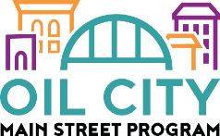**Oil City Main Street Program**

**217 Elm Street, Oil City PA 16301**

**Questions? Please call us:**

Stevette Rosen at (814) 677-3152 ext. 101 or [srosen@oilregion.org](mailto:srosen@oilregion.org)

**(For Office Use Only) Date Received _________ Payment Received ________**